Final Portfolio

At the end of the semester, students will be required to submit a final portfolio that includes a radically revised piece of Creative Nonfiction and a Final Self-Reflection. This portfolio must include all copies of the selected piece from workshop with professor and peer feedback, plus at least one intermediate draft demonstrating self-guided revision.

Assignment:
1) For your Revised Creative Nonfiction, you may revise any piece produced for this class and may choose to adhere to or bend the original parameters as you see fit. You are also welcome to take multiple pieces you wrote during this course and combine them, if appropriate. The expectation here is for “radical revision”— that is to say, you should not be just making minor changes and proofreading.

Radical revision may include: adding or subtracting sections, paragraphs, or significant numbers of sentences; it might involve rearranging the scenes or sections of your piece; you might choose to rewrite a piece from this class in a new style or form (i.e. turning the personal essay into a hermit crab essay); you might choose to take two essays you have written for this class and, if the situation is the same, rewrite them as one piece; or, if you have two very different essays, you might choose to combine them as a braided essay. The possibilities here are nearly endless, but I want to see you take risks, try new things, and through your revision produce an essentially new piece.

Here’s the catch: you must also revise the piece for potential publication in a literary magazine of your choice. This involves reading samples from the magazine to get a sense of the publication’s aesthetic and style. You must also study their submission guidelines and meet the requirements in terms of length, type of essay (if specified), and formatting.

Though you are not required to submit your project, it must still be targeted for a particular literary magazine/journal, and your revised piece should display readiness for submission. Include a ~200 word cover letter which could be included to the editors of the publication which displays your knowledge of their mission/goals/aesthetic. (We’ll look at samples in class.)

This is just a sample of literary magazines you can choose from. You may find more at pw.org

AGNI  Albion Review  Asymptote  Brevity  Collision Literary Magazine  Creative Nonfiction  Fourth Genre: Explorations in Creative Nonfiction  The Gettysburg Review  Granta | Hypertext Magazine  The Massachusetts Review  Michigan Quarterly Review  Prairie Margins  Punctuate: A Nonfiction Magazine  River Teeth: A Journal of Nonfiction Narrative  Solstice: A Magazine of Diverse Voices  The Sun  Susquehanna Review

2) For the Self-Reflection you must defend your revision choices, explaining your process and how the revision best serves the final project. This self-reflection should be more formal and more detailed than those you have produced along the way. You must reference specific changes made in your piece from first draft to final (which may involve quoting yourself) and must create an argument for yourself, proving to the reader why your changes were made and how they improve the effectiveness of the work. You must also acknowledge how your work fits the aesthetic and other requirements of the literary magazine you have chosen.

Submitting the Final Portfolio
You will submit your final project online using Google Drive. To do this, you will need to scan several of your earlier drafts with comments. Instructions are provided on the Portfolio page of our website, and we will discuss and demonstrate in class.

You must create a folder in Google Drive titled with your last name and CNF (i.e. Budris CNF).
Within this folder, you need to create two subfolders: Final Project and Drafts

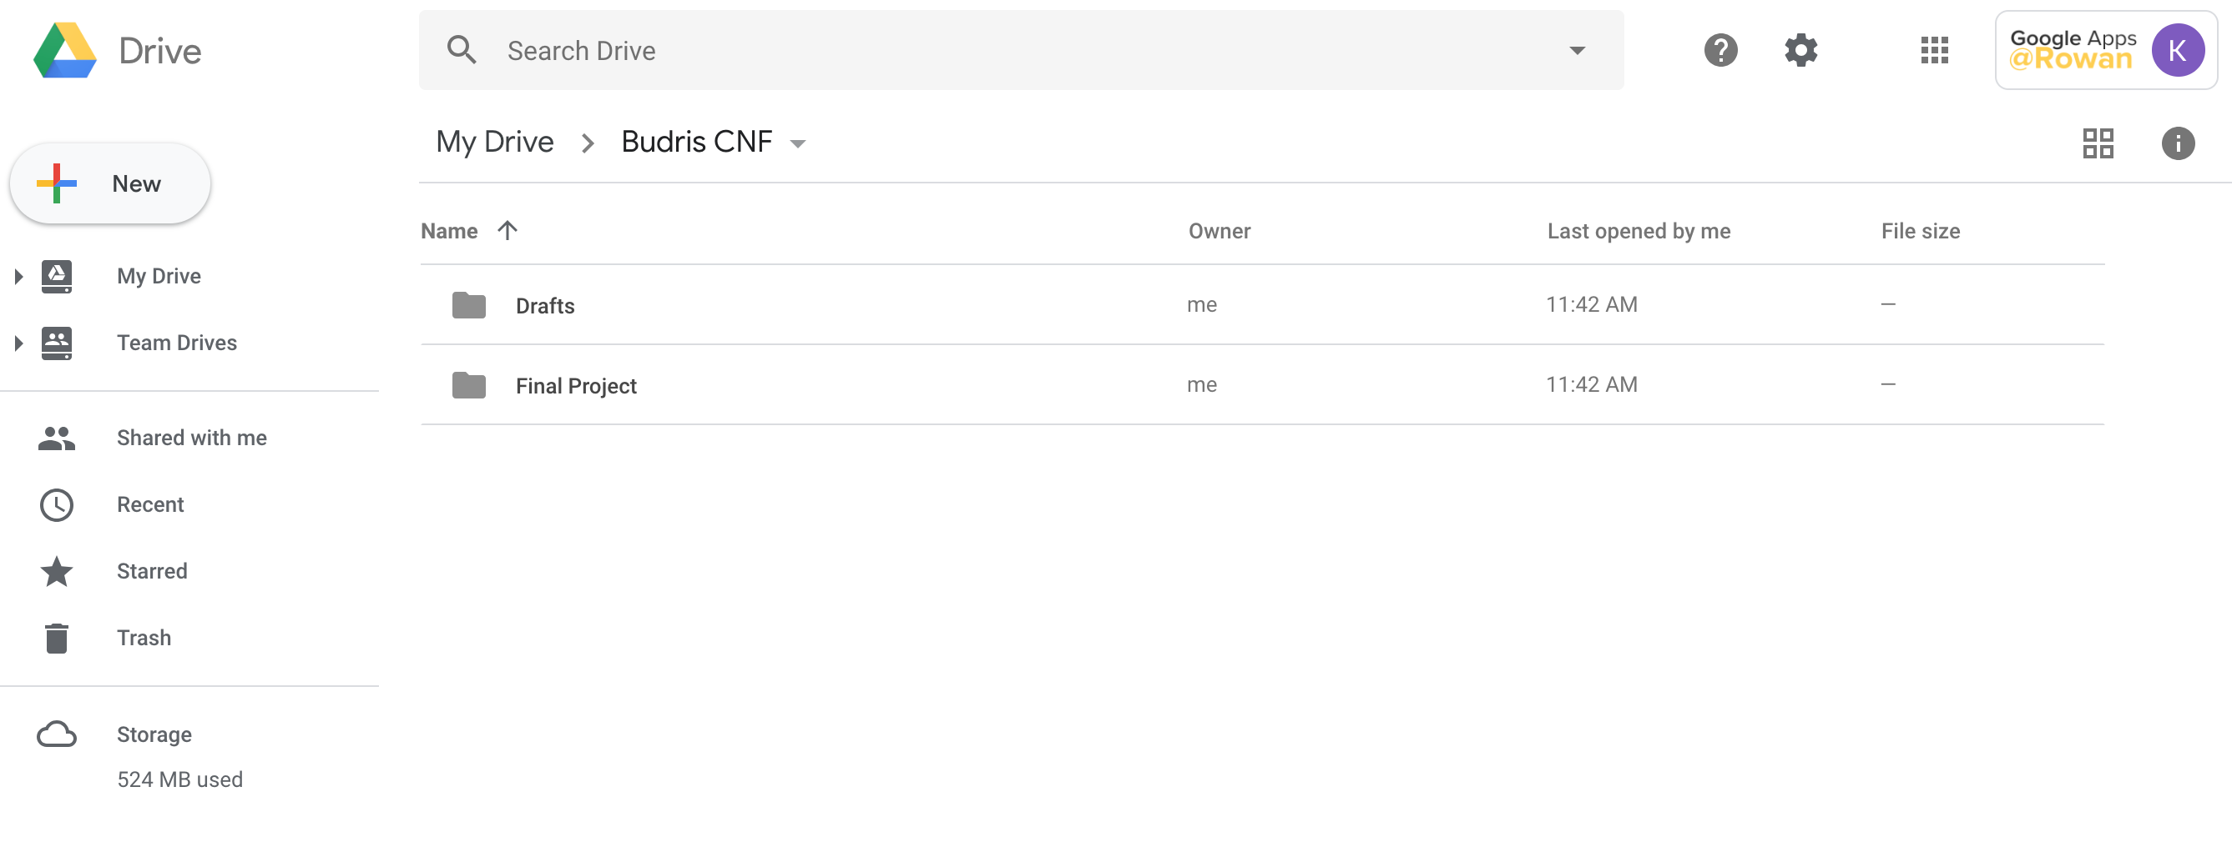
In the Final Project subfolder, upload: (1) your self-reflection, (2) your final revised piece of creative nonfiction, (3) your cover letter to submit to a literary magazine.

In the Drafts subfolder, upload: (1) your scanned drafts with professor comments, (2) scanned drafts with your own notes and/or peer comments, (3) at least one additional draft produced between the original piece and the final copy; this may include notes if you wish.

Share the main folder with your professor:

